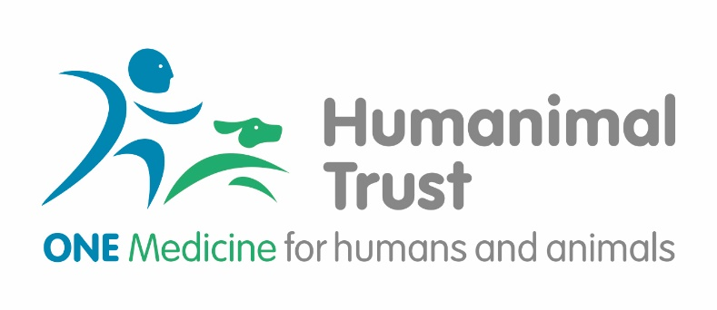
Connections Award Application Form
(Please read the Award Guidance document before completing.)

 | Applicant  (Lead applicant) | Applicant (co-lead) | Co-Applicant 2 | Co-Applicant 3
Title:

First name and initials:
Surname:

Position held:

Institution:

Role in project:

Tel:

Email:

The Proposal

1. Please describe in summary your intended partnership, disease area and goals you would like to achieve during the award (400 words):

2. Please, describe in detail the relevant steps you intend to put in place to develop your partnership and how this may contribute to future collaborative work (1000 word). (e.g. attend mutual clinics and discuss approach and treatment and how possible collaboration could impact on future work)

3. Please, provide detail on how you will use the resources provided for the award (400 words)

4. Please describe what you would like to achieve as a result of the award and your potential future plans (500 words)

THE COSTS

5. Please provide the total cost sought from Humanimal Trust. Please, refer to the Connection Awards guidance for eligible cost. Add rows if required.
Cost description | Named individual | Estimated time contribution | Any other relevant information | Total unit cost | Total cost
 |  |  |  | £ | £
 |  |  |  | £ | £
 |  |  |  | £ | £
 |  |  |  | £ | £
 |  |  |  | £ | £

AUTHORISATIONS

Please ensure you gain the relevant authorisation from heads of department and finance department of your institution (or equivalent legal signatory on behalf of your institution)

By submitting this application form you confirm that you have read Humanimal Trust Grants Guidance and Privacy Policy. If you are successful in your application a separate agreement setting out the conditions of the award will be required. Please note that you will be required to work in partnership with the Humanimal Trust to ensure the impact of the award is promoted in an appropriate way.

Should you need any assistance, please contact: Iva@humanimaltrust.org.uk

