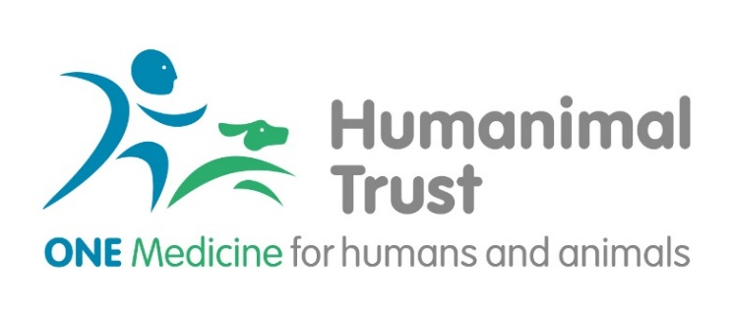
Humanimal Trust Student Project Award
Introduction:
Humanimal Trust drives collaboration between human and animal medical professionals, researchers and allied professions so that all humans and animals benefit from sustainable and equal medical progress, but not at the expense of an animal’s life. This is One Medicine.
The Humanimal Trust funds scientific research that demonstrates reciprocity and advances the cause and ethos of One Medicine. Please, see the Humanimal Trust website for further details.
Humanimal Trust Student Project Award of up to £5,000 aims to support students who are undertaking an undergraduate or post-graduate degree in either medicine, veterinary medicine or other affiliated disciplines (e.g. nursing, dentistry, pharmacy, allied healthcare professionals etc.) who wish to undertake a project related to One Medicine. Projects can include literature review. Where a literature review is undertaken a preference will be given to reviews, which can highlight the use of One Medicine for tackling disease and where questions for future research are identified. Collaboration projects between students of different disciplines will also be considered, and may exceed the listed amount of this award, where considered appropriate.
Students in receipt of the award will be required to present their project at Humanimal Trust organised events (travel cost will be met by Humanimal Trust).
Humanimal Trust research areas of interest to consider:
- Infection control and antimicrobial resistance
- Oncology
- Musculoskeletal Disorders
- Neurology and Neurosurgery
- Regenerative medicine
- Replacement of laboratory animals
- And potentially other projects in any disease area that support the concept of One Medicine (please, contact Humanimal Trust to discuss potential topics)

What Can be Applied for Under the Connections Award?
Humanimal Trust encourages applications for funding in the following categories:
- Any student projects that highlight the benefit of collaboration between human and veterinary medicine.
- Any student projects focused on the areas of interest listed above.
We do not fund the following:
- Any project which involves the use of experimental animal models
- Service provision or audit studies.
- Course fees for degrees or subsistence costs.
- Electives.
- Indirect costs such as administrative or other overheads imposed by an institution.
- Advertising for and recruiting staff.
- 'Top up' funding for work supported by other funding bodies, unless this falls within our specific criteria for seed or top-up funding.
- Attendance at conferences, other than within the specific criteria for our training awards.
- General appeals from other charities. Specific research funding proposals from charity research teams may be considered as part of the standard peer review process.
- Clinical or non-clinical staff training.

Eligibility
The lead applicant must be registered with a higher educational institution (HEI) as a student within relevant discipline. This call is not limited to UK HEIs, and as such students from institutions outside of the UK can apply.
All applicants must be registered as students with an institution for the duration of the grant.

Responsibility of Research Organisations
By submitting a proposal to Humanimal Trust, a research organisation (RO) indicates their formal acceptance of the proposal, their acceptance of the terms and conditions of Humanimal Trust award, and the approval of the salaries and resources sought. Submission also signifies that the RO accepts the terms and conditions and any award-specific terms and conditions, as specified on the award letter, for the entire life of the award. Administrative authorities have responsibility for ensuring that the salaries and resources cited in the proposals are sufficient to undertake the proposed research, to attract sufficiently experienced and skilled staff, represent good value for money, and ensure outputs are publicly shared.

Financial and Justification of Resources
Cost that are eligible under for Student Projects Award:
- Consumables required for project delivery (up to £3000), which may include software licencing for the duration of the project.
- Limited stipend for the project duration (up to £1000).
- Dissemination cost such as Open Access fees – where required, and travel to present project results (up to £1000).

No overhead charges will be covered by this award.
All cost must be justified within the application.

Application Pack
All applicants will be requested to submit the following:
- Cover letter, which provides a justification for the application.
- Application form.
- CV of lead applicant/s and co-applicants if a joint project.
- Gantt chart.
- Support letter from the student supervisor.
- Any declarations of conflict of interest.

Humanimal Trust would also like to encourage both Patient Public Involvement and Engagement (PPIE) as well as Guardian Public Involvement and Engagement (GPIE). We understand that whilst the PPI concept is well evolved in human medical research, it is not yet fully recognised in the veterinary research practice. However, we would encourage applicants to consider the UK Standards for Public Involvement and where possible provide an additional document on consideration of PPIE and GPIE.

