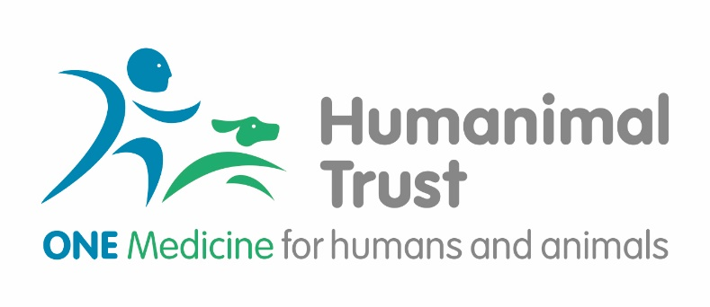
Student Project Award
(Please read the Award Guidance document before completing.)

 | Applicant  (Lead applicant) | Applicant (co-lead) | Co-Applicant 2 | Co-Applicant 3
Title:

First name and initials:
Surname:

Year of study and subject:

Institution:

Role in project:

Tel:

Email:

The Proposal

1. Please provide a summary of your proposed project and how this supports the concept of One Medicine (400 words):

2. Described the details of your project including, background methodology, resource use and timeline. (1500 words)
3. Please, provide detail on how you will use the resources provided for the award (400 words). If you are working in collaboration with another student, please specify the contribution each student will make to the project.

4. Please describe what you would like to achieve as a result of the award and your potential future plans (500 words)

5. References

THE COSTS

6. Please provide the total cost sought from Humanimal Trust. Please, refer to the Award guidance document for eligible cost. Add rows if required.

(Please, note Humanimal Trust does not fund indirect cost at this stage, allocated and direct cost will be supported and assessed against the project design to determine value for money)
Cost description | Unit cost | Quantity |  | Total cost
 |  |  |  | £
 |  |  |  | £
 |  |  |  | £

AUTHORISATIONS

Please ensure you gain the relevant authorisation from your supervisor or heads of department and finance department of your institution (or equivalent legal signatory on behalf of your institution)

By submitting this application form you confirm that you have read Humanimal Trust Grants Guidance and Privacy Policy. If you are successful in your application a separate agreement setting out the conditions of the award will be required. Please note that you will be required to work in partnership with the Humanimal Trust to ensure the impact of the award is promoted in an appropriate way.

Should you require any assistance, please contact: Iva@humanimaltrust.org.uk

