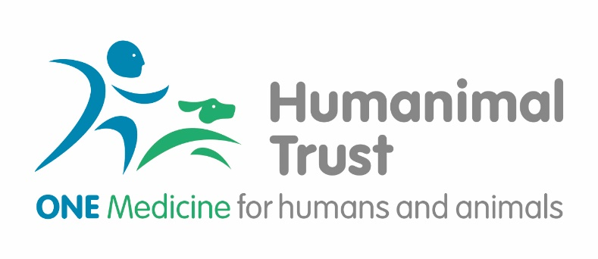

Humanimal Trust - Science Committee Terms of Reference

Purpose of Committee:
Humanimal Trust wishes to support research, which aims to deliver the objectives of Humanimal Trust and bring about a better understanding and implementation of One Medicine. Humanimal Trust will provide funds to support projects, which come under multidisciplinary research in specific clinical areas and also promote the concept of One Medicine internationally. Humanimal Trust Science Committee will assist Humanimal Trust in delivering these key strategic objectives.
All members of the Committee are independent advisors requested to provide independent advice.

Role of the Committee:
To provide the Trustees of Humanimal Trust with recommendations for funding of projects within the framework of current funding opportunities. To provide assurance that projects proposed for funding meet Humanimal Trust requirements and standards as set out by Humanimal Trust. The funding offered can vary from larger grants (e.g. PhD funding) to small project and pump priming grants.
To approve certain funding calls prior to publication.
To receive reports from funded projects and offer recommendations to trustees as regards continuation or cessation of funding, as well as summaries of progress or achievements relating to those projects.
To facilitate the selection and shortlisting in order to make recommendations to the Board of Trustees for funding.
A sub-committee of members will also be created to help prioritisation of funding opportunities for which can be applied for either as a stand-alone entity or in collaboration with other partners (up to 2 members on a rotation basis will form such a sub-committee).
Members of the Committee may, on occasion, be requested to represent the Trust publicly at conferences, meetings and other such events. In such circumstances, all members would be expected to reflect the Trust’s views and policies.

Administration of the Committee
The Committee will be supported by our freelance Research Support Consultant who will provide a summary of the meetings, be responsible for actions recorded from the meeting and support all members of the Committee and all other associated tasks.

Roles, Accountabilities, Responsibilities
The Science Committee is made up of volunteers. Members do not have the same governance responsibilities as Trustees.
The Science Committee is responsible for reviewing applications for Humanimal Trust funding as presented by the research support consultant and making recommendations to the Board of Trustees. The committee can recommend, but cannot approve seed funding, co-funding or major projects as described above.
The Science Committee is expected to apply Humanimal Trust requirements and guidance and assure the Board of trustees that all recommendations for funding meet those requirements.
The Science Committee receives and reviews reports from all funded activities and provides summaries of such reports to the Board of Trustees, along with assurance that such work continues to meet Humanimal standards and requirements, is on schedule and that funding should be continued or ceased.
The Science Committee will provide such advice and guidance to the Board of Trustees as is required to support any recommendations it makes for approval of funding
Although a member of the committee may also be a member of the Expert Panel or a Scientific Ambassador, these roles are defined as distinct from membership of the Science Committee.

Frequency of meetings & Required Commitment
The committee will initially meet twice a year in advance of trustee meetings. This will be reviewed in 2024. It is expected that the commitment will be around 20 hours per year.

Membership of the Committee
The committee is expected to consist of 4-8 members, although this will be reviewed in 2024.
Members must be established experts in relevant fields of science, human or animal health, collectively covering all principal areas of Humanimal Trust interest:

- Infection control and antimicrobial resistance
- Cancer
- Bone and joint disease
- Brain and spine disease
- Regenerative medicine
This is likely to mean at least 8-10 years’ professional experience in a relevant field but qualification will be based on the judgment of the Research Support Consultant and Board of Trustees.
Terms of office are normally three years, after which the Board of Trustees may offer a further term if all parties agree.
We make it clear that members of Humanimal Trust’s Science Committee are contributing in their personal capacity, rather than as formal representatives of their institutions or employers. Any reference to institutions will make it clear that this is for identification or biographical purposes, rather than implying representation.

