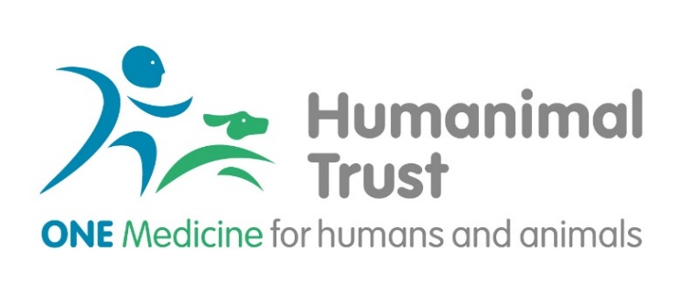
Humanimal Trust Connections Award
Introduction:
Humanimal Trust drives collaboration between human and animal medical professionals, researchers and allied professions so that all humans and animals benefit from sustainable and equal medical progress, but not at the expense of an animal’s life. This is One Medicine.
The Humanimal Trust funds scientific research that demonstrates reciprocity and advances the cause and ethos of One Medicine. Please, see the Humanimal Trust website for further details.
Humanimal Trust Connections Awards aim to support the development of partnership and collaboration between a wide range of human and animal medical/health professionals in order to grow future projects relevant to One Medicine. Humanimal Trust recognises the current limited opportunities that are available to professionals to explore meaningful partnerships and as such has targeted this call to bring together those with a vision of collaborative in future partnerships. Learning and knowledge exchange is based on shared experience, an experience that has the potential to open possibilities for closer working and builds on realisation of similarities as well as differences.
Humanimal Trust research areas of interest to consider:
- Infection control and antimicrobial resistance
- Oncology
- Musculoskeletal Disorders
- Neurology and Neurosurgery
- Regenerative medicine
- Replacement of laboratory animals
- And potentially other projects in any disease area that support the concept of One Medicine (please, contact Humanimal Trust to discuss potential topics)

What Can be Applied for Under the Connections Award?
Humanimal Trust encourages applications for funding in the following categories:
- Development of cross-faculty and cross-departmental partnerships (exploring ideas where collaboration between different faculties can provide answers to human and animal health needs).
- Development of human-veterinary medicine partnership (including visiting exchange to explore specific clinical areas and potential for collaboration).
- Exploring the potential of building a specific partnership within a specific clinical area.
We do not fund the following:
- Any project which involves the use of experimental animal models
- Service provision or audit studies.
- Higher education courses fees
- Course fees for degrees or subsistence costs.
- Electives
- Indirect costs such as administrative or other overheads imposed by an institution.
- Advertising for and recruiting staff.
- 'Top up' funding for work supported by other funding bodies, unless this falls within our specific criteria for seed or top-up funding.
- Attendance at conferences (other than related to this award, however, those should be discussed separately and do not form part of this award)
- General appeals from other charities. Specific research funding proposals from charity research teams may be considered as part of the standard peer review process.
- Clinical or non-clinical staff training.

Eligibility
The lead applicant must have an institutional affiliation with a higher education institution (HEI) in the UK, or veterinary practice, or the NHS or a private medical institution/practice based in the UK. In exceptional circumstances consideration will be given to individuals based outside of the UK who have close links to a UK institution. UK based applicants collaborating with institutions outside of the UK would be eligible to apply.
All applicants must be either employed or be registered as students with an institution for the duration of the grant.

Responsibility of Research Organisations
By submitting a proposal to Humanimal Trust, a research organisation (RO) indicates their formal acceptance of the proposal, their acceptance of the terms and conditions of Humanimal Trust award, and the approval of the salaries and resources sought. Submission also signifies that the RO accepts the terms and conditions and any award-specific terms and conditions, as specified on the award letter, for the entire life of the award. Administrative authorities have responsibility for ensuring that the salaries and resources cited in the proposals are sufficient to undertake the proposed research, to attract sufficiently experienced and skilled staff, represent good value for money, and ensure outputs are publicly shared.

Financial and Justification of Resources
Cost that are eligible under for Connections Award:
- Travel cost between collaborating partners (up to £2500 per award with possibility to extend to £4000 if the partner organisation is outside of the UK).
- Proportion of staff costs involved – to cover release from clinical duties where required (up to £3000).
- Production of any materials to support the building of the collaboration (up to £1000).

No overhead charges will be covered by this award.
All cost must be justified within the application.

Application Pack
All applicants will be requested to submit the following:
- Cover letter, which provides a justification for the application.
- Application form.
- CV of lead applicants (joint applicants) and all co-applicants with brief statement indicating support for the application
- Gantt chart.
- Support letter of the lead institution and collaborating institution of applicable.
- Any declarations of conflict of interest.

Humanimal Trust would also like to encourage both Patient Public Involvement and Engagement (PPIE) as well as Guardian Public Involvement and Engagement (GPIE). We understand that whilst the PPI concept is well evolved in human medical research, it is not yet fully recognised in the veterinary research practice. However, we would encourage applicants to consider the UK Standards for Public Involvement and where possible provide an additional document on consideration of PPIE and GPIE.

