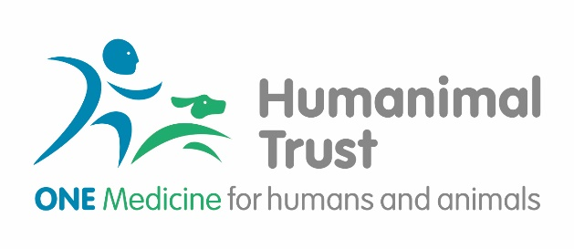
Ambassador Application Form
Role Applied for:
Full name (including title)
Address
Postcode
Contact Telephone Number(s)
E-mail
Please outline why you are applying to volunteer as an Ambassador with Humanimal Trust (please continue on a separate sheet if necessary)

Please tell us about any relevant skills, experience or qualifications for this role (do refer to the Role Description for the position you are applying for and continue on a separate sheet if needed):

Do you have any particular circumstances or health needs that we should be aware of? (We ask this so that we can best support you volunteering as an Ambassador with us - any information will be treated in confidence.)

Rehabilitation of Offenders Act (1974):
Do you have unspent criminal convictions registered against you (please delete as appropriate)? Yes/No
If Yes, this may not prevent you volunteering, but please provide details of any conviction in a
sealed envelope addressed to the Development Manager at Humanimal Trust, Hatch Suite – Surrey Place, Mill Lane, Godalming, Surrey GU7 1EY

Do you hold any other voluntary roles with other organisations?
If yes please provide details:
How did you hear about volunteering opportunities at Humanimal Trust?

References
Full name (including title) |  | Full name  (including title)
Address |  | Address
Postcode |  | Postcode
Contact Telephone Number(s) |  | Contact  Telephone  Number(s)
E-mail |  | E-mail
Occupation |  | Occupation
How Known to You |  | How Known to You

Emergency Contact Details
Please supply the details of someone we can contact in case of an emergency:
Name
Telephone (Home/Work/Mobile)
Address
(If different from above)
Relationship to You:

Declaration
I understand that Humanimal Trust will use my information for administrative and management purposes in accordance with Data Protection legislation. I confirm that I understand that if shortlisted I will be asked to attend an interview for this role (either in person or via online video – Facetime, Skype, etc.) and if successful, an induction.
I confirm that I have completed this Volunteer Ambassador application with wholly accurate information at the time of submission and am over the age of 18 years.
Signed: Date:
Please return your fully completed form to info@humanimaltrust.org.uk or print and post to:
Humanimal Trust
Hatch Suite – Surrey Place
Mill Lane, Godalming
Surrey, GU7 1EY

